**ECE 414 – Embedded Systems**

**Report for Lab 03 – Software State Machines and Timers**

GuoYuan Li (Scribe)

Harry Zhu

Sep 17, 2020

**1. Introduction**

The objective of this lab is to learn to write basic synchronous state machines in C programs to capture time-ordered behaviors in an embedded system as well as to understand the use of timers in PIC32. In addition, it is intended to learn how to debounce a press button in software and design both software and hardware implementation of a board game on MCU PIC32, which will be described detailedly in the next section.

**2. Requirements**

The goal of this lab is to design a simple 1 dimension Pong game, where an lightened LED represents the “ball”, and was designed using multiple synchronous state machines, including the button debouncers and ball(LED) position tracker. Specifically, it has the following requirements:

1. The ball is randomly assigned to one of the players and the LED closest to that player is lighted indicating he/she should serve.
2. When that player presses the button, the game begins and the ball travels from one LED to the next toward the other player.
3. When the ball reaches the LED adjacent to the other player's button, that player must “hit" the ball by pressing the button, which causes the ball to travel in the opposite direction.
4. The ball travels back and forth in this way until one of the players “misses" by not pressing the button when it is at the end or by pressing the button when it is not over the end.
5. When a player misses, the LED nearest the winning player flashes a few times (at least 3). Then go back to step (a) and repeat.
6. The speed of the game shall vary, starting with a delay of approximately 300ms between ball movements and gradually increasing at the end of each turn up to a "Ball" Left "Paddle" Button LEDs Right "Paddle" Button 2 delay of approximately 100ms.
7. The delay shall return to 300ms when the system is reset.
8. Pushbutton inputs shall be debounced in software

**3. Design Description**

**3.1 Hardware Description**

In order to simulate a game similar to a one-dimensional version of “air hockey” which is essentially a ball bouncing between two ends, the hardware implementation can be broken into three fundamental parts. First part of the hardware implementation is the PIC32 microprocessor, used to store the program and having the I/O connected to it. Eleven of the microprocessor pins are used in the implementation, among which three are input ports and eight are output ports. Second part is the LEDs, which can be generally considered as the output of our system. Eight LEDs are used in the game, in which they form a line as the path for the ball to move on. In the game players have to be on either side of the LED line preventing the ball to hit the end of the line without bouncing back. An eight-bit output signal is connected to the eight LEDs, as each bit represents one of the LEDs. Each LED is connected to a resistor which connects to one of the RB pins of the microprocessor. The third part is the input devices. Three buttons are used in the game as input devices, two of which represent either side of player input, and the third button as the reset button for the game to restart. The three input buttons are connected to three RA ports configured as input pins of the microprocessor.

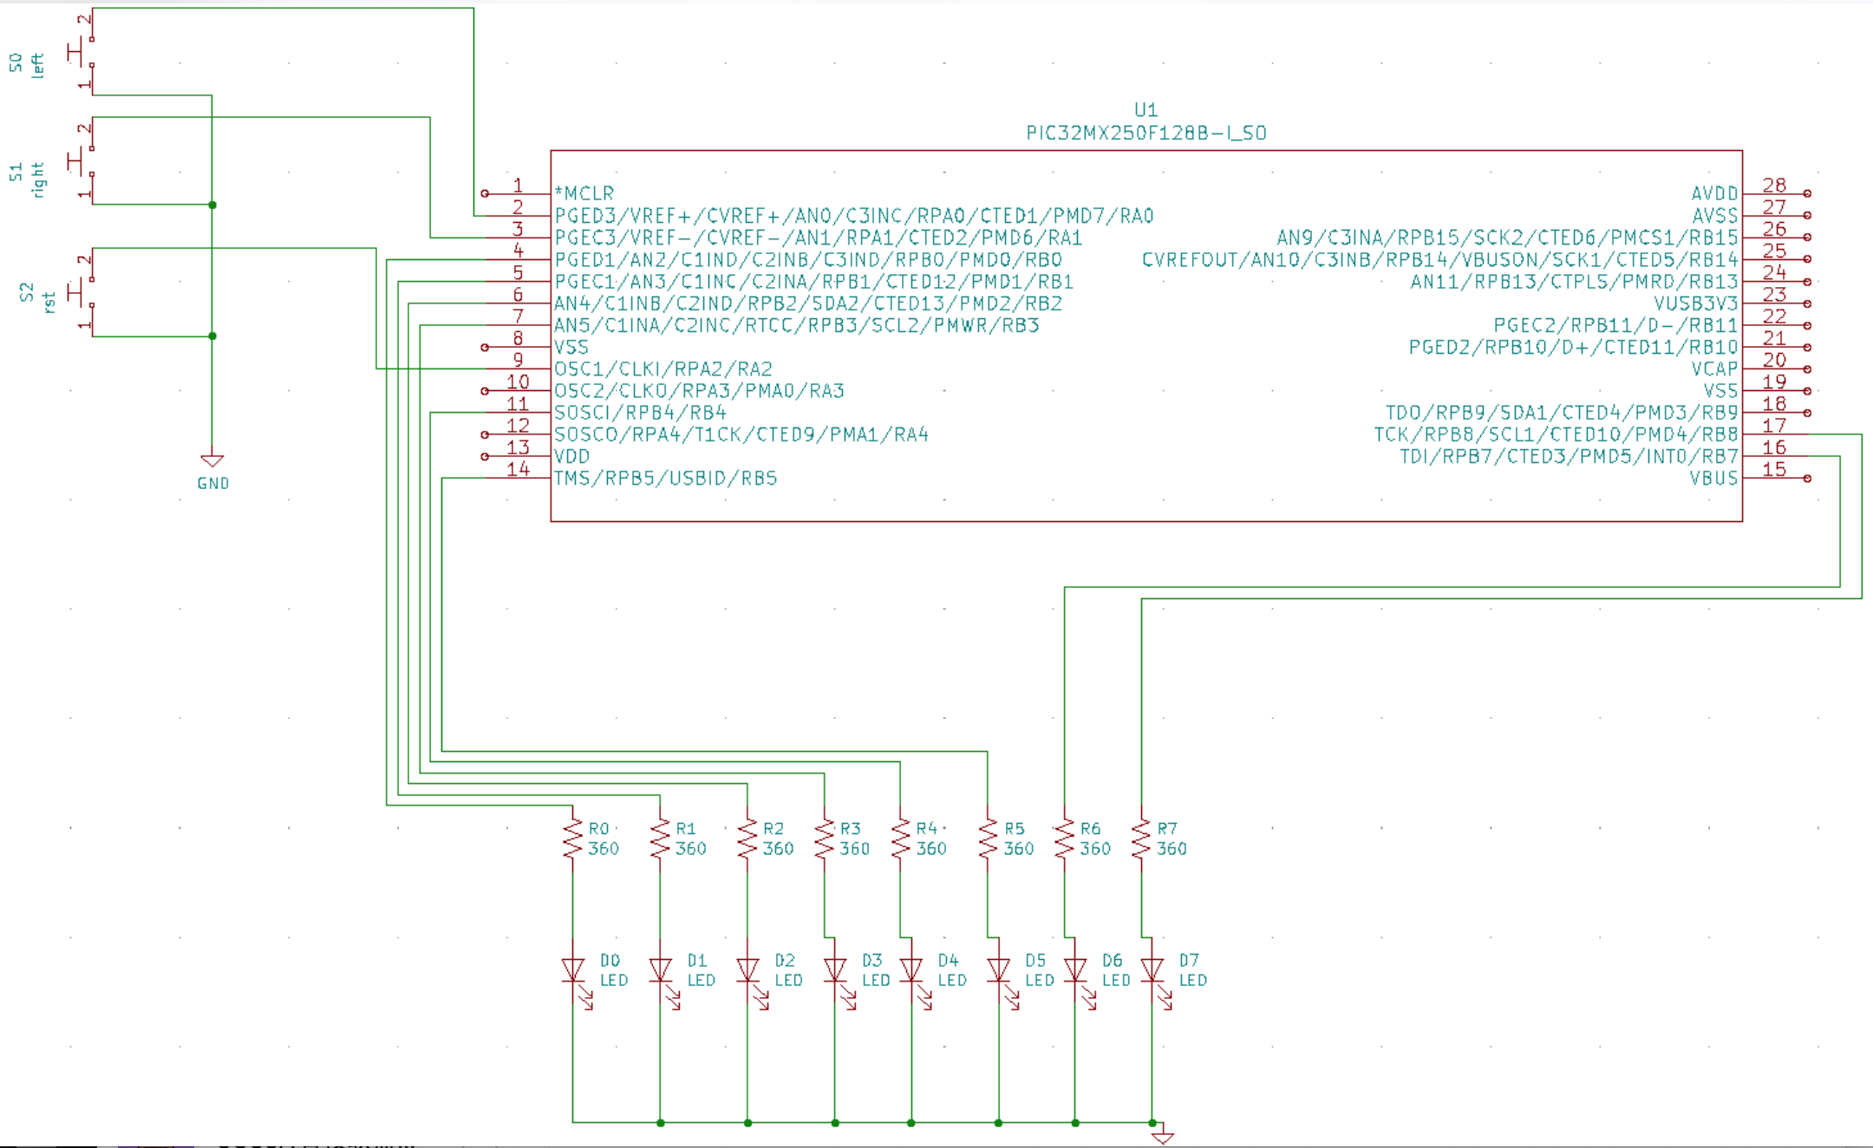

Figure 1. Hardware Schematic Diagram

**b. Software architecture**

**Global Variables**:

The program will have 3 8-bit global variables.

-**count:** This variable is initialized to 0 and increments by 1 in the while(1) loop.

**-dir**: Calculated from masking “count” by 0x01. This variable “dir” decides who serves the ball. Since “count” is always counting and the least significant bit is either 0 or 1 with 50/50 chances, it is reasonable to assume that the 2 players have equal chances to serve the ball.

-**period:** the shared time period for Ball_Tracker module and the button_debouncers.

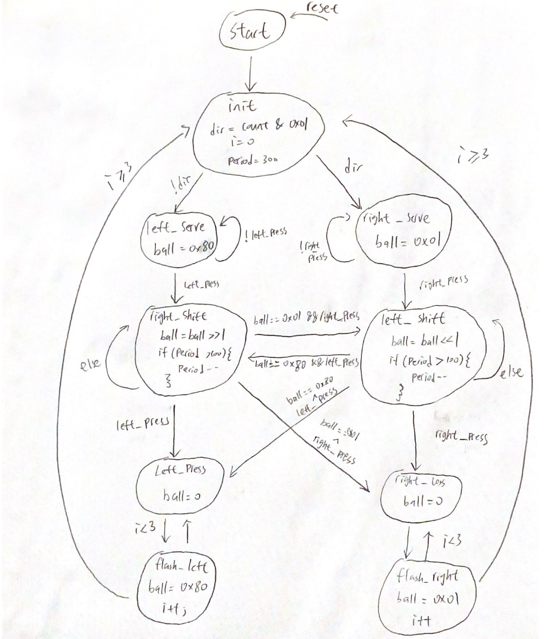

Figure 2. Ball_Tracker state machine state diagram

This Ball_Tracker FSM is the main module tracking the ball’s position. It has a local 8-bit variable called “ball,” the output. In addition, the FSM receives left press and right press as inputs from the button_debouncer module, which is included next. There is a start state where the FSM is initialized to. Then, it automatically goes to the init state, where the server is assigned. The FSM randomly assigns a player to serve according to “dir.” If “dir” is 0, the FSM enters left_serve state, meaning left player serves. If “dir” is 1, the FSM enters the right_serve state, meaning the right player serves. The FSM waits for the right or left button to be pressed in the corresponding serve state. The ball will be assigned to the endpoint accordingly. If the signal left press or right press is high, the FSM will shift to corresponding shift state, either left shift or right shift. In the shift states, the LED is shifting in the corresponding direction and the time period is decreasing by 1, if greater than 100, each time to make the shifting faster. If the ball is shifting and the opposite player presses the button, the opponent loses, the FSM enters corresponding loss state. If the ball reaches the end point and the player fails to press the button, he or she loses and FSM enters the corresponding loss state. If the player presses the button on time when the ball is at the end point, the FSM goes to the state with opposite shift direction. If one player loses, the LED closest will flash 3 times and return to init state, where the process repeats.

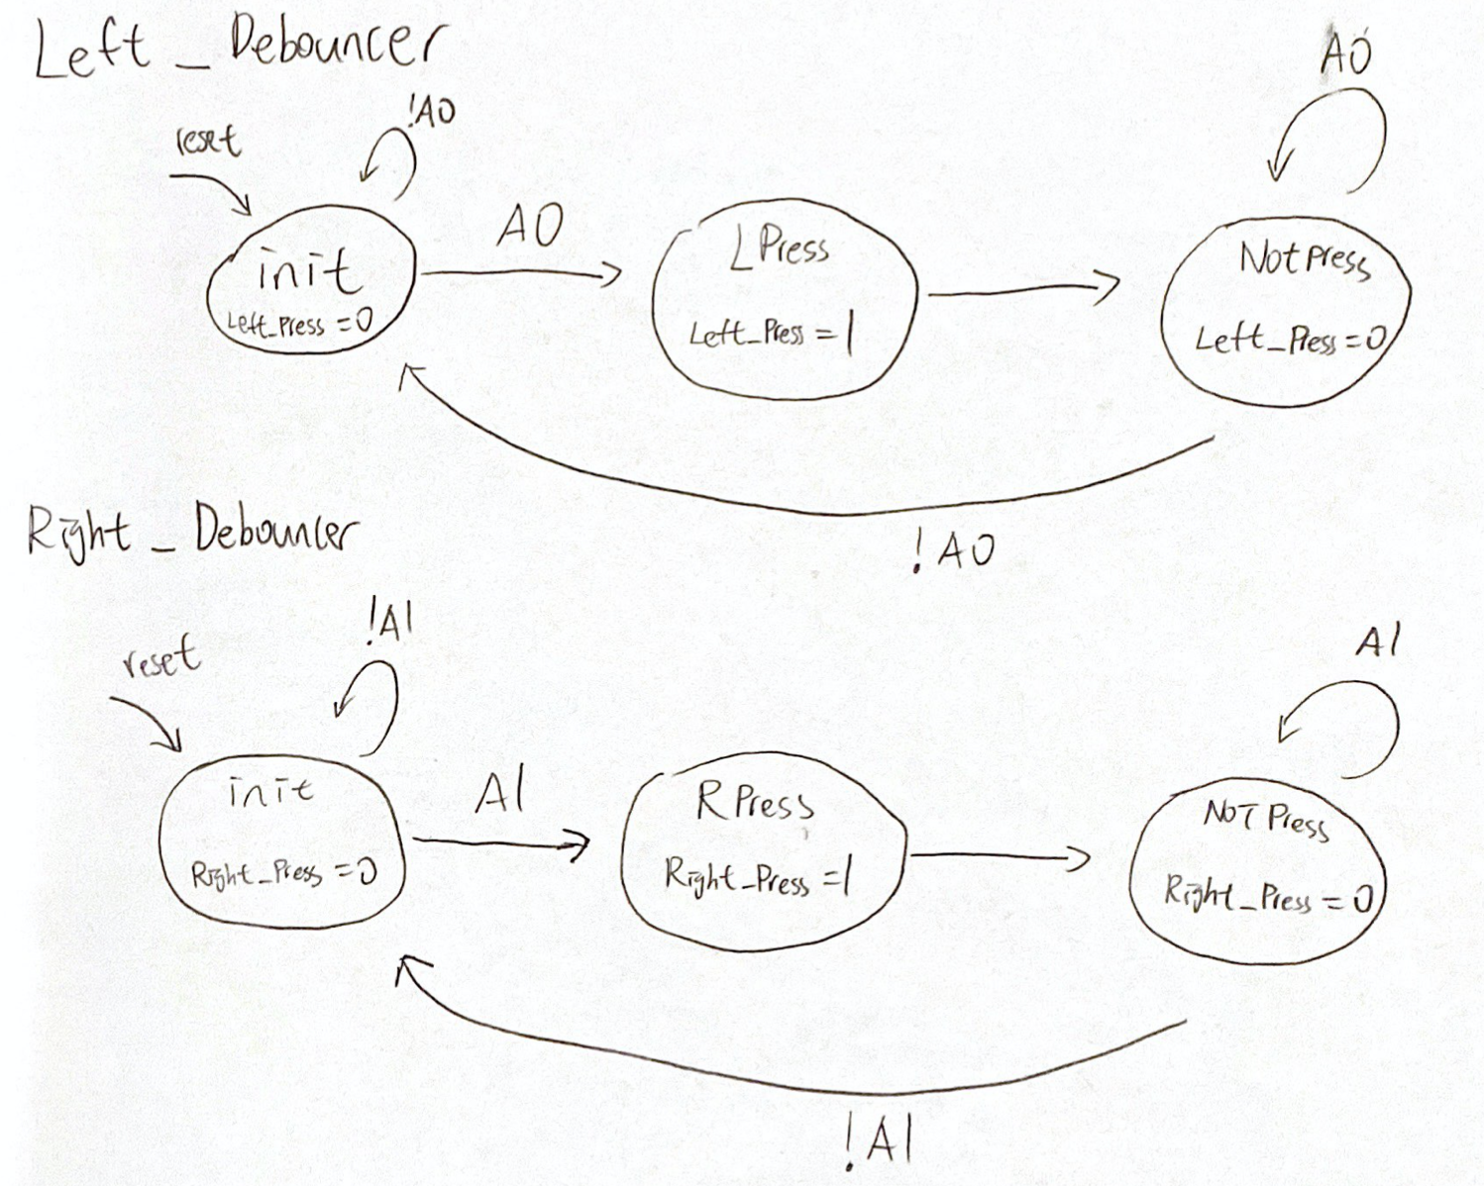

Figure 3. Switch Debounce State diagram

**Button_Debouncer Description:** This button_debouncer FSM includes both Left_Debouncer and Right_Debouncer that helps to filter the signal fluctuations and generate a single pulse. The left and right button debouncers behave the same except setting different “press” signals to high. They all begin with an init state, waiting for either A1 and A0 to be asserted high(can be done by using in & 0x01). If A1 or A0 is asserted, the FSM enters either LPress or RPress state that asserts the press signal accordingly. Then, the FSM automatically enters the NOTPress state where it waits for A1 or A0 to fall. It will then go back to the init state when the signal drops.

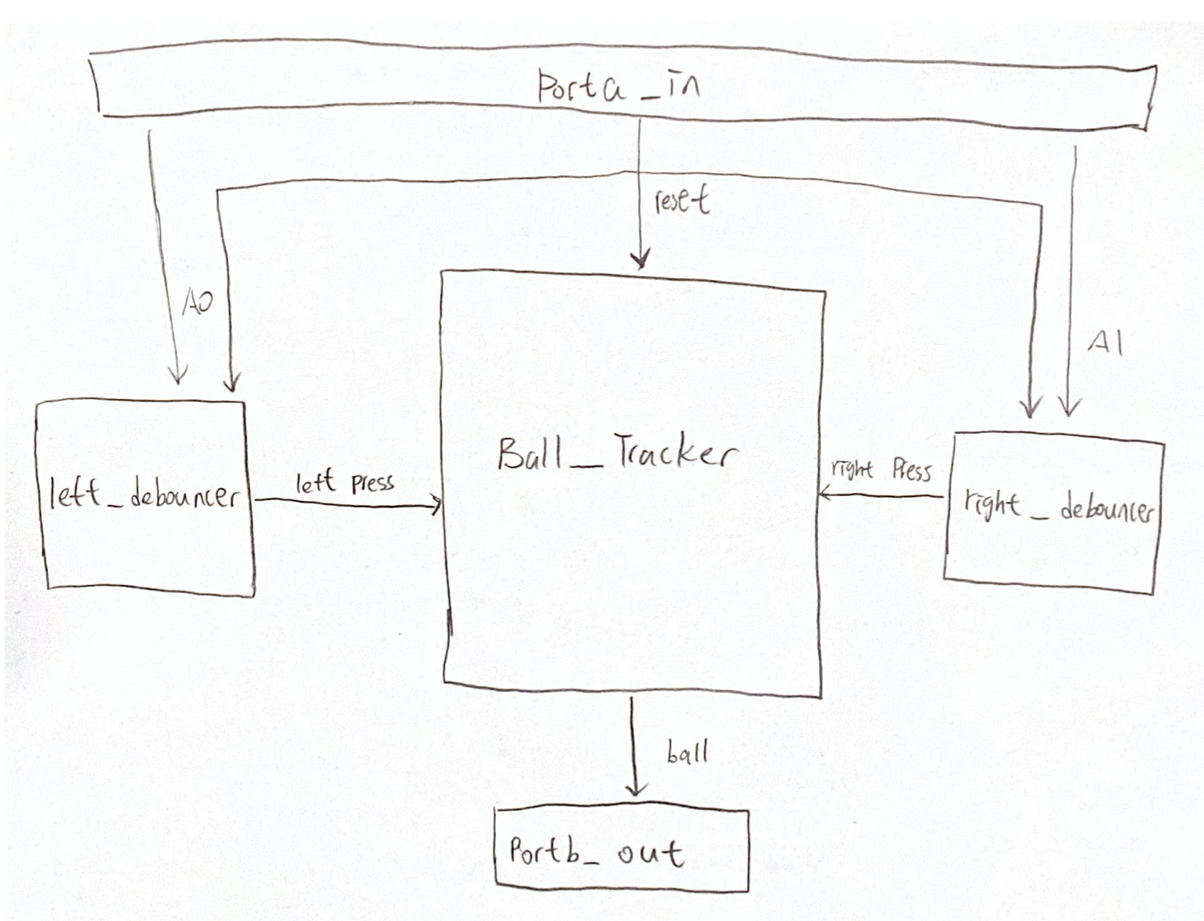

Figure 4. High level Block Diagram

**High Level Block Diagram Description:** There are 5 major modules in this project, namely Porta_in, left_debouncer, right_debouncer, Ball_Tracker, and Portb_out. The first is the Porta_in module, which receives an 8-bit input from the left and right button. It outputs A0 and A1 by masking the 8-bit input by 0x01 and 0x02. A0 and A1 will then feed into left_debouncer and right_debouncer as inputs. These debouncers will output corresponding button_press signals to the Ball_Tracker module. All 3 of these modules receive a common synchronous reset signal from Porta_in, which is A2 generated by masking input by 0x04. Finally, Ball_Tracker outputs a 8-bit “ball” to Portb_out, indicating the position of the ball using LED display.

**4. Test Plan.**

This section describes a test plan that will include:

**a. Unit testing**

* Modules Porta_in and Portb_out are assumed to work well since they behaved perfectly in the previous lab project.
* The Left_Debouncer and Right_Debouncer modules can be tested with additional codes and hardware. For example, a code can be written that lights an LED up when the signal of either Left_press or Right_Pressed is asserted when the either button is pressed.
* The Ball_fsm module will be tested using additional code together with the Porta_in, Portb_out, and hardware to see if the state transitions are correct by looking at the shiftings or flashings of the LEDs. In addition, the debouncers and Ball_Tracker can be tested together
* Timer1 module will be tested integrated with the ball and the debouncers through observing the behavior of hardware, such as the shifting speed of LEDs, to verify its correctness and capability of tracking time.

**b. Acceptance testing**

This section describes the tests to be performed to test the correctness of the system. Requirements verified for each test will be shown in the traceability matrix in figure 5.

* **T1: Starts the System**
  + **Pass**: Ball is randomly assigned to an endpoint for the player at the side to serve.
  + **Fail**: Ball is not showing up on the endpoints or multiple LED light up.
* **T2: Left or right layer presses button to serve**
  + **Pass**: the ball is served from the end point and proceeds toward the opposite direction. The speed should be relatively slow at 300ms.
  + **Fail**: ball is not moving or to a wrong direction. Speed is already high and not like 300ms.
* **T3: Player presses button when the LED at player’s side is lit**
  + **Pass**: LED shifts toward opposite direction from the end
  + **Fail**: LED does not shift to opposite direction from the end
* **T4: Player presses button when the LED has not yet reached to the player’s end** 
  + **Pass**: LED stops shifting, indicating a loss. The LED at the opponent side flashes for 3 times. A new game starts by assigning a server randomly, ball shifting speed recovers to be slower at 300ms
  + **Fail:** ball continue shifting like nothing happened
* **T5: Opponent presses button before the player “hitting back the ball”**
  + **Pass**: the opponent loses the game, LED at the opponent side flashes for 3 times. A new game starts by assigning a server randomly, LED shifting speed recovers to be slower at 300ms
  + **Fail**: Nothing happens and game continues
* **T6: One player misses the ball**
  + **Pass**: the closest LED to the player who just lost flashes on and off for three times and a new game starts by assigning a server randomly, ball shifting speed recovers to be slower at 300ms
  + **Fail:** Wrong or no LED lights up and system is stuck at loss, shifting speed is not recover to 300ms
* **T7: Observe the shifting speed of the “ball”**
  + **Pass**: the shifting speed is increasing over time and gradually reaches to 100ms per LED.
  + **Fail**: the speed doesn’t change or gets slower
* **T8: Reset button is pressed,** 
  + **Pass**: ball is randomly assigned to an endpoint and period recovers to 300ms
  + Fail: nothing happens or speed is not recovered
* **T9: Press the button many times**
  + **Pass**: System senses pressing and enters correct states, either shifting in opposition position or loss
  + **Fail**: System does not respond to the pressing, indicating a failure has occurred in the debouncer.

|  |  |  |  |  |  |  |  |  |  |
| --- | --- | --- | --- | --- | --- | --- | --- | --- | --- |
|  | **Requirements** | | | | | | | | **Results** |
| **Tests (Performer)** | **2.1** | **2.2** | **2.3** | **2.4** | **2.5** | **2.6** | **2.7** | **2.8** | **Pass** |
| **T1. GuoYuan** | **x** | **x** |  |  |  |  |  |  | **Pass** |
| **T2. GuoYuan** | **x** | **x** |  |  |  | **x** |  | **x** | **Pass** |
| **T3. GuoYuan** |  | **x** | **x** | **x** |  |  | **x** | **x** | **Pass** |
| **T4. GuoYuan** |  |  |  | **x** | **x** | **x** | **x** | **x** | **Pass** |
| **T5. Harry** |  |  | **x** | **x** | **x** | **x** | **x** | **x** | **Pass** |
| **T6. Harry** |  |  |  | **x** | **x** | **x** | **x** | **x** | **Pass** |
| **T7. Harry** |  |  |  |  |  | **x** | **x** |  | **Pass** |
| **T8. Harry** | **x** | **x** |  |  |  |  | **x** | **x** | **Pass** |
| **T9. Harry** |  | **x** | **x** | **x** |  |  |  | **x** | **Pass** |

**Figure 5. Traceability Matrix**

**5. Conclusion**

The lab went successfully as all the tests were passed and all the requirements were satisfied. We’ve learned how to construct state diagrams and design synchronous state machines, as well as explored further in writing C programs by learning the module structure and functions. In addition, we gained familiarity with input/output configurations by learning the software and hardware implementation of DIP pushbuttons. We spent approximately 3 hours in this lab.

**6. Software Implementation**

**main.c**

#pragma config FNOSC = FRCPLL, POSCMOD = OFF

#pragma config FPLLIDIV = DIV_2, FPLLMUL = MUL_20

#pragma config FPBDIV = DIV_1, FPLLODIV = DIV_2

#pragma config FWDTEN = OFF, JTAGEN = OFF, FSOSCEN = OFF

#include <xc.h>

#include <stdio.h>

#include <inttypes.h>

#include "ball_fsm.h"

#include "left_debounce.h"

#include "right_debounce.h"

#include "reset_debounce.h"

#include "portb_out.h"

#include "porta_in.h"

#include "timer1.h"

main(){

uint16_t t1, t2;

uint16_t period = 300;

uint8_t count = 0;

uint8_t reset, left_press, right_press;

timer1_init();

init_Ball();

reset_Debounce_init();

right_Debounce_init();

left_Debounce_init();

t1 = timer1_read();

while (1) {

t2 = timer1_read();

count++;

if (timer1_elapsed_ms(t1, t2) >= period) {

t1 = t2;

reset = reset_Debounce();

left_press = left_Debounce();

right_press = right_Debounce();

tickFct_Ball(count, &period, reset, left_press, right_press);

}

}

return (EXIT_SUCCESS);

}

**Ball_fsm.h**

#ifndef BALL_FSM_H

#define BALL_FSM_H

#include <inttypes.h>

#include "portb_out.h"

extern void init_Ball();

extern void tickFct_Ball(uint8_t count, uint16_t *period, uint8_t reset, uint8_t left_press, uint8_t right_press);

#endif

**ball_fsm.c**

#include <xc.h>

#include <inttypes.h>

#include "portb_out.h"

static enum Ball_States { Ball_SMStart, Ball_init, Ball_leftserve, Ball_rightserve,

Ball_leftshift, Ball_rightshift, Ball_leftloss, Ball_rightloss, Ball_flashleft,

Ball_flashright}Ball_State;

//variables

uint8_t i;

uint8_t ball;

uint8_t dir;

void init_Ball(){

Ball_State = Ball_SMStart;

portb_out_init();

}

void tickFct_Ball(uint8_t count, uint16_t *period, uint8_t reset, uint8_t left_press,

uint8_t right_press)

{

//reset

if(reset){

Ball_State = Ball_SMStart;

}

//Transition

switch (Ball_State) {

case Ball_SMStart:

Ball_State = Ball_init;

break;

case Ball_init:

if(!dir){

Ball_State = Ball_leftserve;

}else{

Ball_State = Ball_rightserve;

}

break;

case Ball_leftserve:

if(left_press){

Ball_State = Ball_rightshift;

}else{

Ball_State = Ball_leftserve;

}

break;

case Ball_rightserve:

if(right_press){

Ball_State = Ball_leftshift;

}else{

Ball_State = Ball_rightserve;

}

break;

case Ball_leftshift:

if((ball==0x80) && left_press){

Ball_State = Ball_rightshift;

}else if(right_press){

Ball_State = Ball_rightloss;

}else if((ball==0x80)^left_press){

Ball_State = Ball_leftloss;

}else{

Ball_State = Ball_leftshift;

}

break;

case Ball_rightshift:

if((ball == 0x01) && right_press){

Ball_State = Ball_leftshift;

}else if(left_press){

Ball_State = Ball_leftloss;

}else if((ball == 0x01)^right_press){

Ball_State = Ball_rightloss;

}else{

Ball_State = Ball_rightshift;

}

break;

case Ball_leftloss:

Ball_State = Ball_flashleft;

break;

case Ball_rightloss:

Ball_State = Ball_flashright;

break;

case Ball_flashleft:

if(i<3){

Ball_State = Ball_leftloss;

}else{

Ball_State = Ball_init;

}

break;

case Ball_flashright:

if(i<3){

Ball_State = Ball_rightloss;

}else{

Ball_State = Ball_init;

}

break;

default:

Ball_State = Ball_SMStart;

break;

}

//Action

switch(Ball_State){

case Ball_SMStart:

ball = 0xFF;

portb_out_write(ball);

break;

case Ball_init:

dir = count & 0x01;

i = 0;

*period = 300;

ball = 0;

portb_out_write(ball);

break;

case Ball_leftserve:

ball = 0x80;

portb_out_write(ball);

break;

case Ball_rightserve:

ball = 0x01;

portb_out_write(ball);

break;

case Ball_leftshift:

ball = ball << 1;

portb_out_write(ball);

if(*period > 100){

*period = *period - 5;

}

break;

case Ball_rightshift:

ball = ball >> 1;

portb_out_write(ball);

if(*period > 100){

*period = *period - 5;

}

break;

case Ball_leftloss:

ball = 0;//0x00

portb_out_write(ball);

break;

case Ball_rightloss:

ball = 0;//0x00

portb_out_write(ball);

break;

case Ball_flashleft:

ball = 0x80;

portb_out_write(ball);

i++;

break;

case Ball_flashright:

ball = 0x01;

portb_out_write(ball);

i++;

break;

default:

ball = 0;

i = 0;

break;

}

}

**Left_debounce.h**

#ifndef LEFT_DEBOUNCE_H

#define LEFT_DEBOUNCE_H

#include <inttypes.h>

#include "porta_in.h"

extern void left_Debounce_init();

extern uint8_t left_Debounce();

#endif

**left_Debounce.c**

#include <xc.h>

#include <inttypes.h>

#include "porta_in.h"

static enum out3_States{init, press, debounce}out3_States;

void left_Debounce_init()

{

out3_States = init;

}

uint8_t left_Debounce()

{

uint8_t button = porta_in_read();

uint8_t out = 0;

switch(out3_States){

//left switch

case init:

if(button & 0x01){

out3_States = press;

}

else{

out3_States = init;

}

break;

case press:

out3_States = debounce;

break;

case debounce:

if(!button){

out3_States = init;

}

else{

out3_States = debounce;

}

break;

default:

out3_States = init;

break;

}

switch(out3_States){

case init:

out = 0;

break;

case press:

out = 1;

break;

case debounce:

out = 0;

break;

default:

out = 0;

break;

}

return out;

}

**Right_debounce.c**

#include <xc.h>

#include <inttypes.h>

#include "porta_in.h"

static enum out3_States{init, press, debounce}out3_States;

void right_Debounce_init()

{

out3_States = init;

}

uint8_t right_Debounce()

{

uint8_t button = porta_in_read();

uint8_t out = 0;

switch(out3_States){

//left switch

case init:

if(button & 0x02){

out3_States = press;

}

else{

out3_States = init;

}

break;

case press:

out3_States = debounce;

break;

case debounce:

if(!button){

out3_States = init;

}

else{

out3_States = debounce;

}

break;

default:

out3_States = init;

break;

}

switch(out3_States){

case init:

out = 0;

break;

case press:

out = 1;

break;

case debounce:

out = 0;

break;

default:

out = 0;

break;

}

return out;

}

**Reset_Debounce.c**

#include <xc.h>

#include <inttypes.h>

#include "porta_in.h"

static enum out3_States{init, press, debounce}out3_States;

void reset_Debounce_init()

{

out3_States = init;

porta_in_init();

}

uint8_t reset_Debounce()

{

uint8_t button = porta_in_read();

uint8_t out = 0;

switch(out3_States){

//left switch

case init:

if(button & 0x04){

out3_States = press;

}

else{

out3_States = init;

}

break;

case press:

out3_States = debounce;

break;

case debounce:

if(!button){

out3_States = init;

}

else{

out3_States = debounce;

}

break;

default:

out3_States = init;

break;

}

switch(out3_States){

case init:

out = 0;

break;

case press:

out = 1;

break;

case debounce:

out = 0;

break;

default:

out = 0;

break;

}

return out;

}

**Timer1.h**

#ifndef TIMER1_H

#define TIMER1_H

#include <stdint.h>

#include <inttypes.h>

extern void timer1_init();

extern uint16_t timer1_read();

extern uint16_t timer1_elapsed_ms(uint16_t t1, uint16_t t2 );

#endif

**timer1.c**

#include <stdint.h>

#include <xc.h>

#include "timer1.h"

#define CLOCK_FREQ 40000000

void timer1_init() {

T1CON = 0x8030; // Timer 1 on, prescale=256

TMR1 = 0;

}

uint16_t timer1_read() {

return TMR1;

}

uint16_t inline ticks_to_ms(uint16_t dt) {

return ((uint32_t)dt * 256) / (CLOCK_FREQ/1000);

}

uint16_t timer1_elapsed_ms (uint16_t t1, uint16_t t2 ) {

if (t2 >= t1)

{

return ticks_to_ms(t2-t1);

}

else

{

return ticks_to_ms((uint32_t)(65536 + t2 - t1));

}

}

**Porta_in.h**

#ifndef PORTA_IN_H

#define PORTA_IN_H

#include <inttypes.h>

extern void porta_in_init();

extern uint8_t porta_in_read();

#endif

**Porta_in.c**

#include <xc.h>

#include <inttypes.h>

#include "porta_in.h"

void porta_in_init() {

// low-level code to

// initialize port

ANSELA = 0;

TRISA = 0x03;

}

uint8_t porta_in_read() {

// low-level code to

// read port

return (PORTA & 0x03); //0x1F

}

**Portb_out.h**

#ifndef PORTB_OUT_H

#define PORTB_OUT_H

#include <inttypes.h>

extern void portb_out_init();

extern void portb_out_write(uint16_t val);

#endif

**Portb_out.c**

#include <xc.h>

#include <inttypes.h>

#include "portb_out.h"

void portb_out_init() {

// low-level code to

// initialize port

ANSELB = 0;

TRISB = 0;

}

void portb_out_write(uint16_t val)

{

// low-level code to

// write port

uint16_t temp1 = val & 0x003F;

uint16_t temp2 = (val & 0x07C0) << 1;

uint16_t temp3 = (val & 0x3800) << 2;

LATB = temp1 | temp2 | temp3;

}